Evidence of good collaboration

Good communication and file sharing
Receivable evidence includes:
- Emails and other types of messages (Facebook messenger, WhatsApp etc.)
- Screenshots of Basecamp conversations in which you actively participate.
- Screenshots showing files (designs, reports) that you shared with your team on Basecamp
Important: Please include no more than 5 items
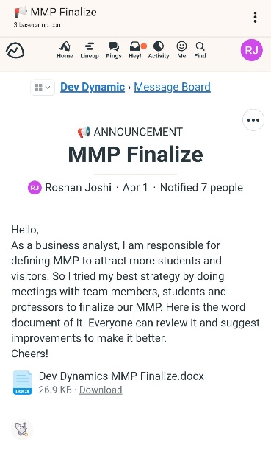 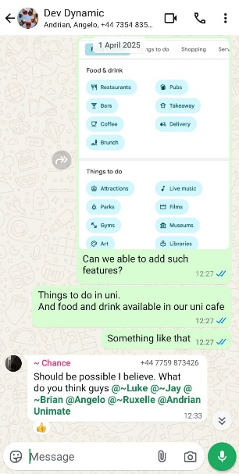 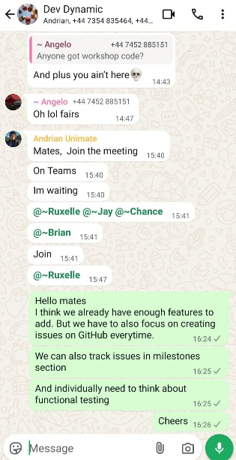 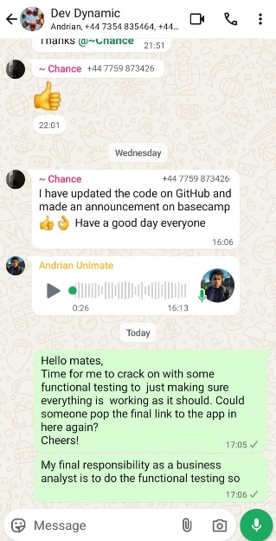 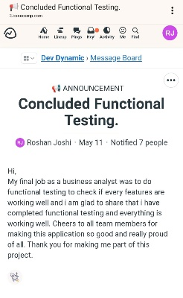Image 1: I provided MMP file here as I was responsible for it being business analyst.
Image 2: It shows my effort to provide best features for MMP.
Image 3: I was motivating team members for creating issues on GitHub after I finalize MMP.
Image 4: I was asking for final link for our application to do functional testing.
Image 5: It shows I completed functional testing which was my final responsibility and also I appreciated my team members here.
Continuing Personal Development (CPD)
Receivable evidence includes:
- Course/seminar attendance register
- Online course: certificate of completion
- Word document summarising what was learnt and how it can be used on the project
Important: Please include no more than 5 items
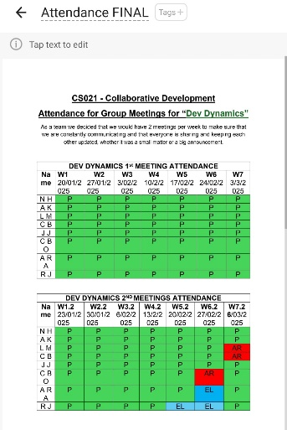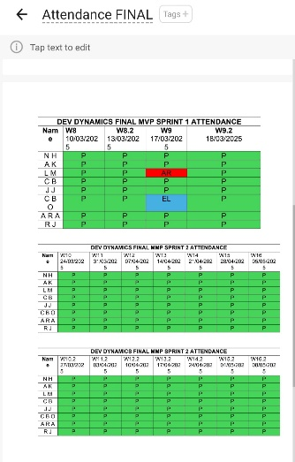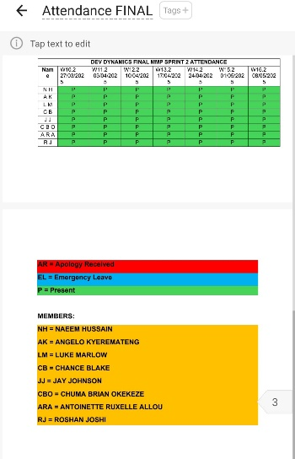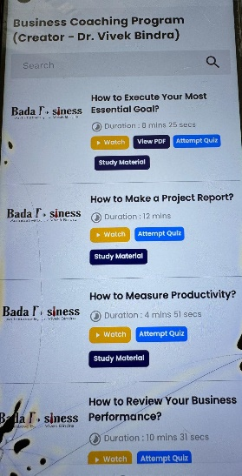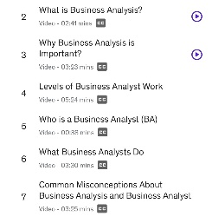
Image 1, 2, &3: Attendance sheets
Image 4: I took Subscription of international business coach Dr. Vivek Bindra to understand more about role of business analyst and report writing.
Image 5: I also used Udemy platform to gain more information.

Issue tracking
Receivable evidence includes:
- Screenshots of personal contributions to GitLab issues.
Important: Please include no more than 5 items
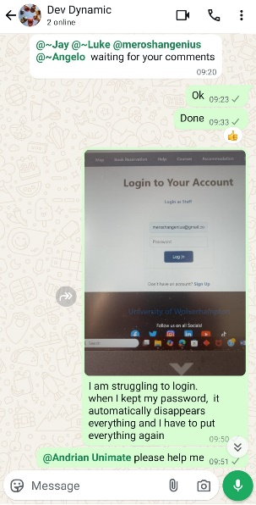
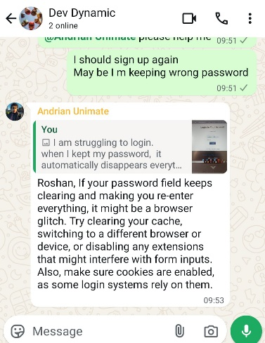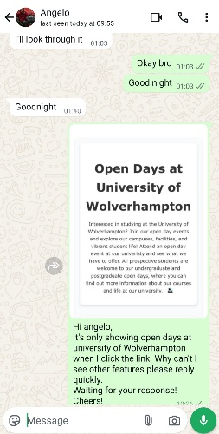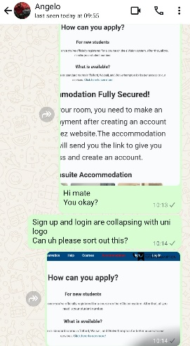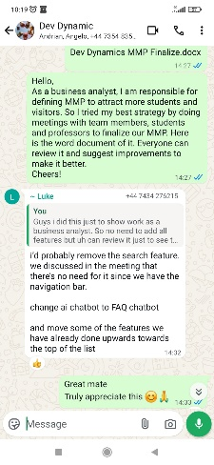
Image 1 & 2: I raised issue of struggling to login and PM helped me.
Image 3: It only show first page of our app when I click the link and software developer helped me to access it properly.
Image 4: university logo was collapsing with login and signup then software developer fixed it.
Image 5: When my team members point out mistake in MMP then I correct the wrong part.

Work to deadlines
No evidence required. Your tutor will decide whether you have worked to deadlines based on various factors (team meetings, discussions with other team members, discussion with client etc.)

